



**ADV-EXCEL WITH AI**



# **INDEX**

**INDEX**

**CHAPTER 1-INTRODUCTION TO MS-EXCEL**

CELL

INTERFACE:

TABS AND RIBBONS

NAVIGATION TIPS

OFFICE BUTTON

**CHAPTER 2. ENTERING, EDITING AND FORMATTING DATA**

Entering Data in a Cell

Editing the contents of a cell

Deleting the contents of a cell

Replacing the contents of a cell

Selecting multiple cells

Selecting columns

Selecting rows

Saving your workbook

Change the font style and size for a worksheet

AutoFill

Align a column or row

Change the orientation of text in a cell

CUT, COPY, AND PASTE

Move cells by using Cut and Paste

UNDO & REDO

FIND & REPLACE

CELL STYLES:

**CHAPTER 3 FORMATTING NUMBERS**

Format Painter

**CHAPTER 4-MANAGING WORKSHEET**

Naming and Moving & Copying Worksheet

Grouping Worksheets

FEATURES IN HOME TAB:

Formatting Fonts

Change Font Color:

Borders on a worksheet

CREATE A CUSTOM CELL BORDER STYLE

Draw cell border

Wrap text

Merge and unmerge cells

CHAPTER 5 – MODIFYING ROWS & COLUMNS

INSERTING & DELETING A ROW AND COLUMN

CHANGING AND RESIZING THE WIDTH & HEIGHT

Set a column to a specific width:

Change the column width to automatically fit the contents:

Change the width of the column by using mouse:

Hiding and Unhiding Rows and Columns

**CHAPTER 6: UNDERSTANDING FORMULAS**

Create a simple formula in Excel

Use AutoSum

How to copy formula down a column

Cell References

CHAPTER 7: CHANGING VIEWS

Workbook Views

Zoom Features

Freeze Panes

Split a sheet into panes

View multiple sheets in one workbook

View multiple workbooks

Minimize The Ribbon

CHAPTER 8 AUTOFILL AND CUSTOM LISTS

AutoFill Non-Adjacent Cells

Creating Custom Lists

Create your own custom list

Series Formatting

CHAPTER 9 CONDITIONAL FORMATTING

Conditional Formatting

Highlight Cell Rules

Appearance Options

Excel Top/Bottom Rules

Data Bars

Icon Sets

Options

Create a Custom Conditional Formatting Rule

# 

# **CHAPTER 1-INTRODUCTION TO MS-EXCEL**

Microsoft excel is an application that is used for recording, analysing and visualizing data.it is in the form of a spreadsheet.  It consists of individual cells that can be used to build functions, formulas, tables, and graphs that easily organize and analyse large amounts of information and data.

## CELL

A cell is a rectangular area formed by the intersection of a column and a row. Cells are identified by the Cell Name. It can hold different types of data (Text, Number, Date and Formulas)

Row is a sequence of cells along a horizontal line.

Column is a sequence of cells along a vertical line

Rows are identified by number and columns are identified by name

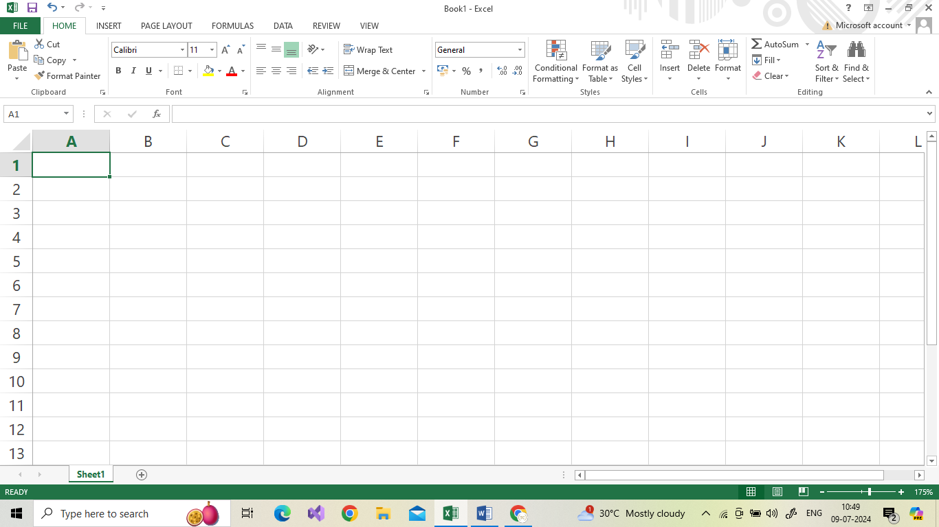

|  |  |
| --- | --- |
| Rows | 10,48,578 rows starting from 1 to 10,48,578 |
| Columns | 16,384 columns starting from A to XFD(A,B,C,,,,,,AA,AB,AC) |
| Worksheet | Maximum of 255 sheets can be inserted |

## INTERFACE:

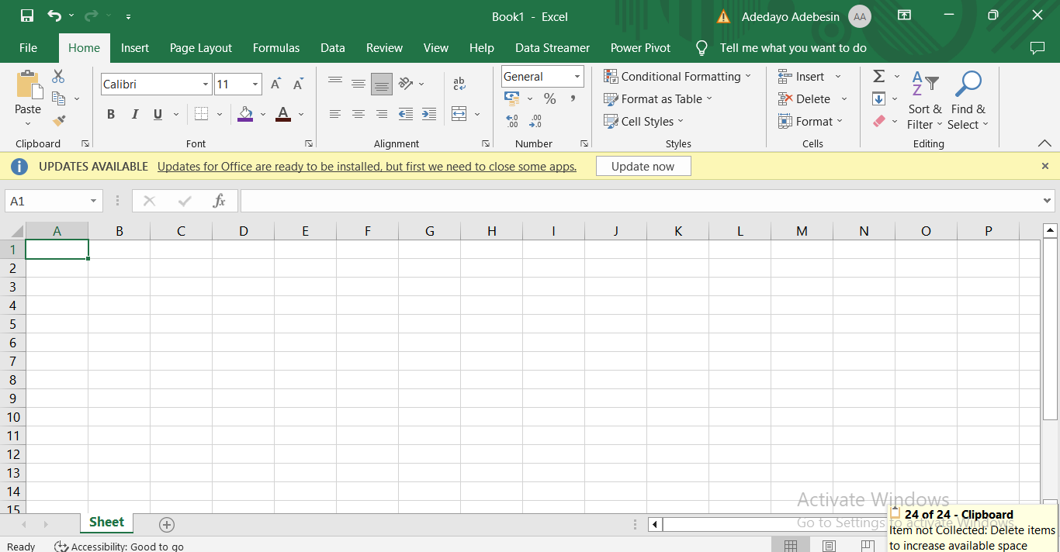

## TABS AND RIBBONS

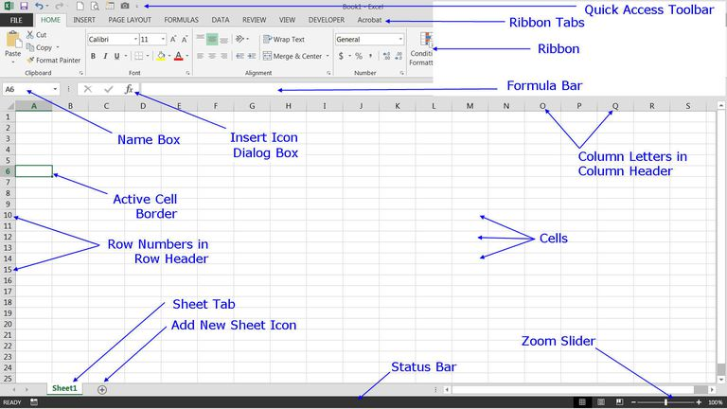

## NAVIGATION TIPS

↑ - Up one cell

↓ - Down one cell

← - Moves Left one cell

→ - Moves Right one cell

**Ctrl + → =** Goes to the furthest right of the current spreadsheet

**Ctrl + ← =** Goes to the furthest left of the current spreadsheet

## OFFICE BUTTON

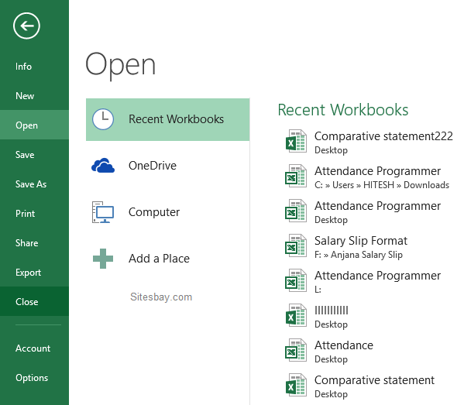

# **CHAPTER 2. ENTERING, EDITING AND FORMATTING DATA**

## Entering Data in a Cell

1. Click on the Cell
2. Type the Text
3. Press Enter

## Editing the contents of a cell

1. Double-click on the cell required. A cursor will appear inside the cell

## Deleting the contents of a cell

1. Click on the cell required
2. Press delete key

## Replacing the contents of a cell

1. Click on the cell required
2. Type the new contents

## Selecting multiple cells

1. Using the mouse to select cells
2. For selection your mouse pointer must look like the  big white plus sign.

## Selecting columns

1. Click on the column letter you require or click and drag over the column letters to select several columns.

## Selecting rows

1. Click on the row number you require or click and drag over the row number to select several rows

## Saving your workbook

1. The first time you save a workbook in Excel you have to specify a name for the file, once you have done this you can click on the familiar save icon to update the changes you have made.

STEPS:

1. Click on the office button
2. Click **File** > **Save As**.
3. Click **Computer**.
4. Click **Browse** to find the location you want in your **Documents** folder.
5. In the **File name** box, enter a name for a new workbook
6. To save your workbook in a different file format (like .xls or .txt), in the Save as type list (under the File name box), pick the format you want.
7. Click Save(CTRL+ S)

## Change the font style and size for a worksheet

When you enter data in a worksheet, Excel automatically uses the Calibri font style in size11 but if you prefer a different font style or size, here’s how you can change them

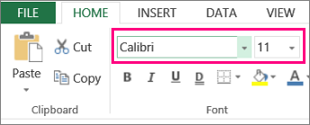

To change font size, click the arrow next to the default **Font Size** and pick the size you want.

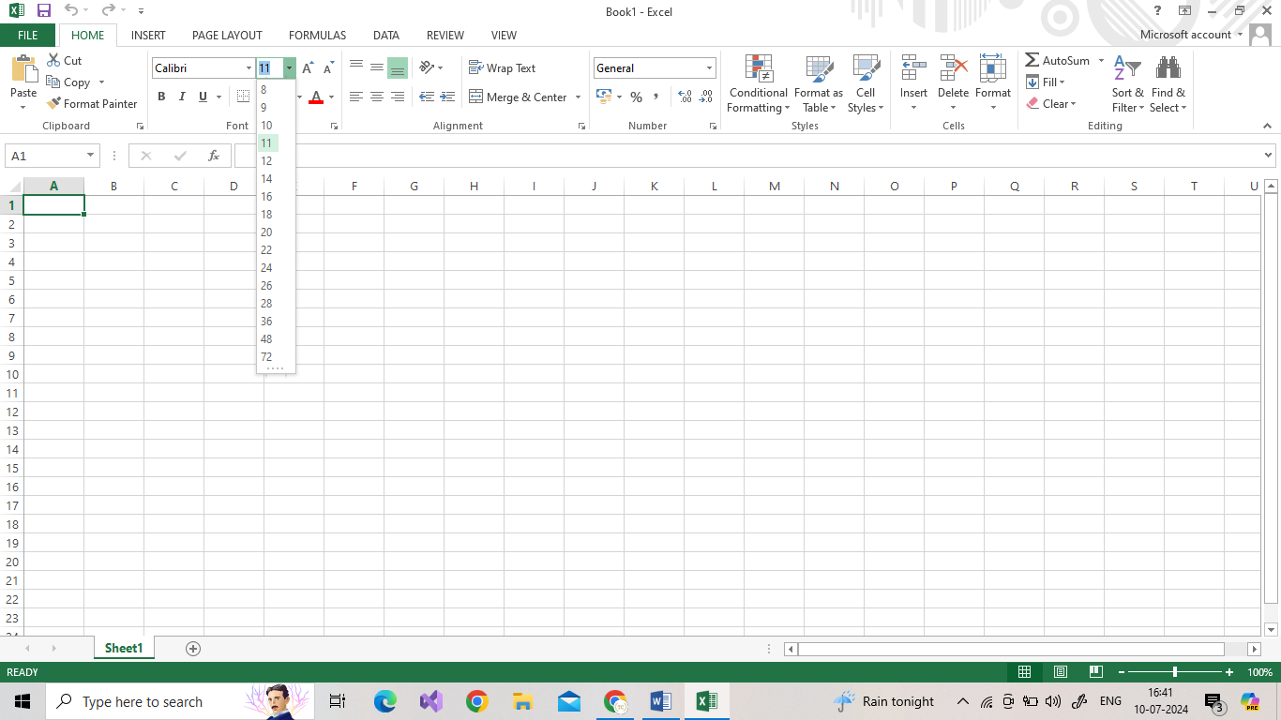

## AutoFill

Excel has a feature that helps you automatically enter data. If you are entering a predictable series (e.g. 1, 2, 3…; days of the week; hours of the day) you can use the AutoFill command to automatically extend the sequence.

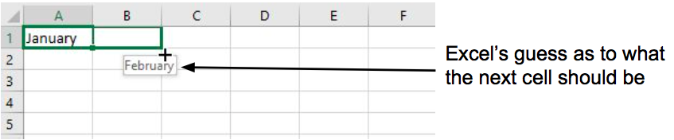

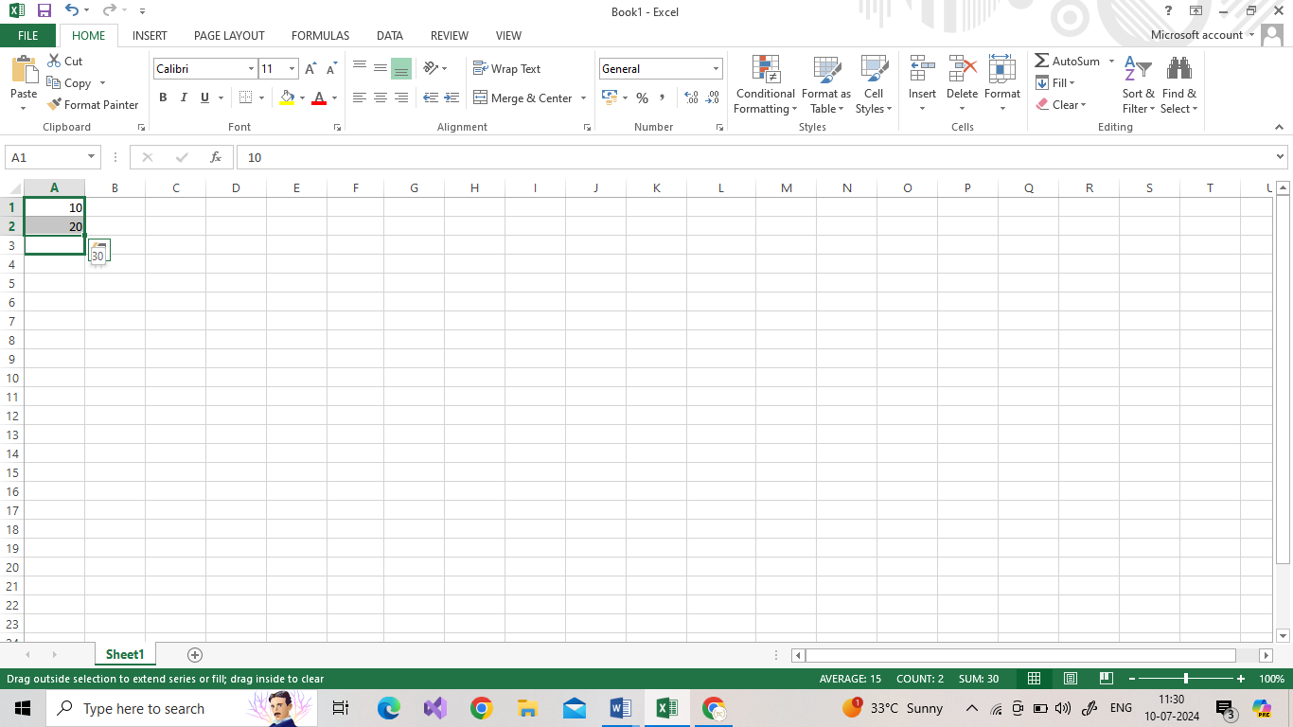

## Align a column or row

1. Select the cells you want to align.
2. On the **Home** tab, in the **Alignment** group, select a horizontal alignment option:

|  |  |  |
| --- | --- | --- |
| The Center button.The Align Left button  **Align Left** | **Center** | The Align Right button.  **Align Right** |

1. On the **Home** tab, in the **Alignment** group, select a vertical alignment option:

|  |  |  |
| --- | --- | --- |
| The Top Align button.  **Top Align** | The Middle Align button.  **Middle Align** | The Bottom Align button.  **Bottom Align** |

## Change the orientation of text in a cell

1. Select a cell, row, column, or a range.
2. Select **Home** > **Orientation**  The Orientation option in Excel helps you rotate text in a cell., and then select an option.

You can rotate your text up, down, clockwise, or counter clockwise, or align text vertically:

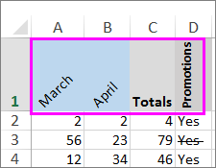

## CUT, COPY, AND PASTE

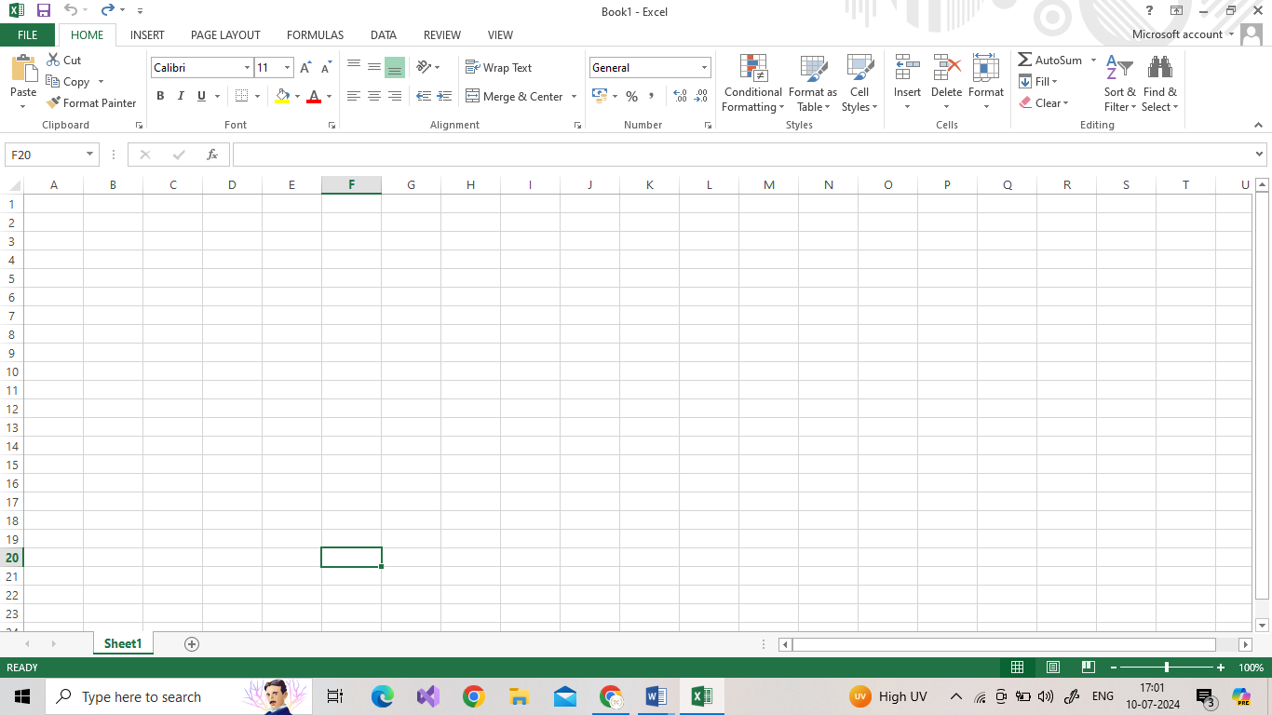

### Move cells by using Cut and Paste

Select a cell or a cell range.

1. Select **Home** > **Cut** or press **Ctrl + X**.
2. Select a cell where you want to move the data.
3. Select **Home** > **Paste** or press **Ctrl + V.**

**Copy cells by using Copy and Paste**

1. Select the cell or range of cells.
2. Select **Copy** or press **Ctrl + C.**
3. Select **Paste** or press **Ctrl + V.**

## UNDO & REDO

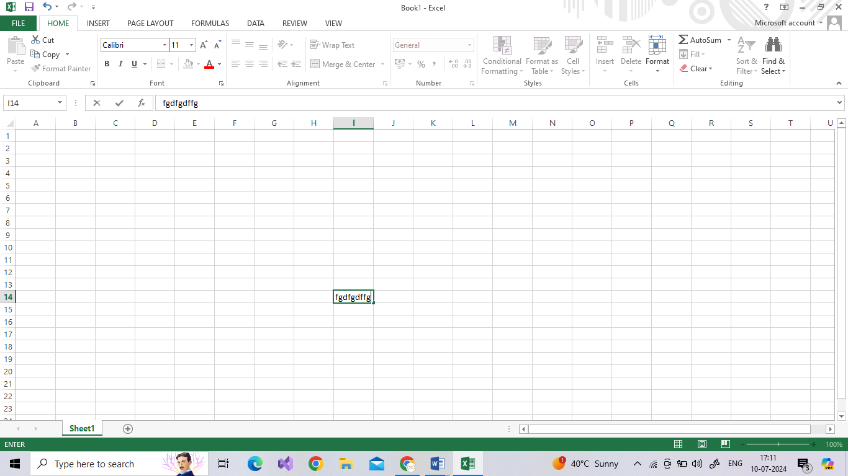

**UNDO:**

To undo an action press **Ctrl + Z** on your keyboard, or select **Undo** on the Quick Access Toolbar. You can press Undo (or Ctrl + Z) repeatedly if you want to undo multiple steps.

**REDO:**

To redo something you've undone, press Ctrl+ Y or select Redo on the Quick Access toolbar.

## FIND & REPLACE

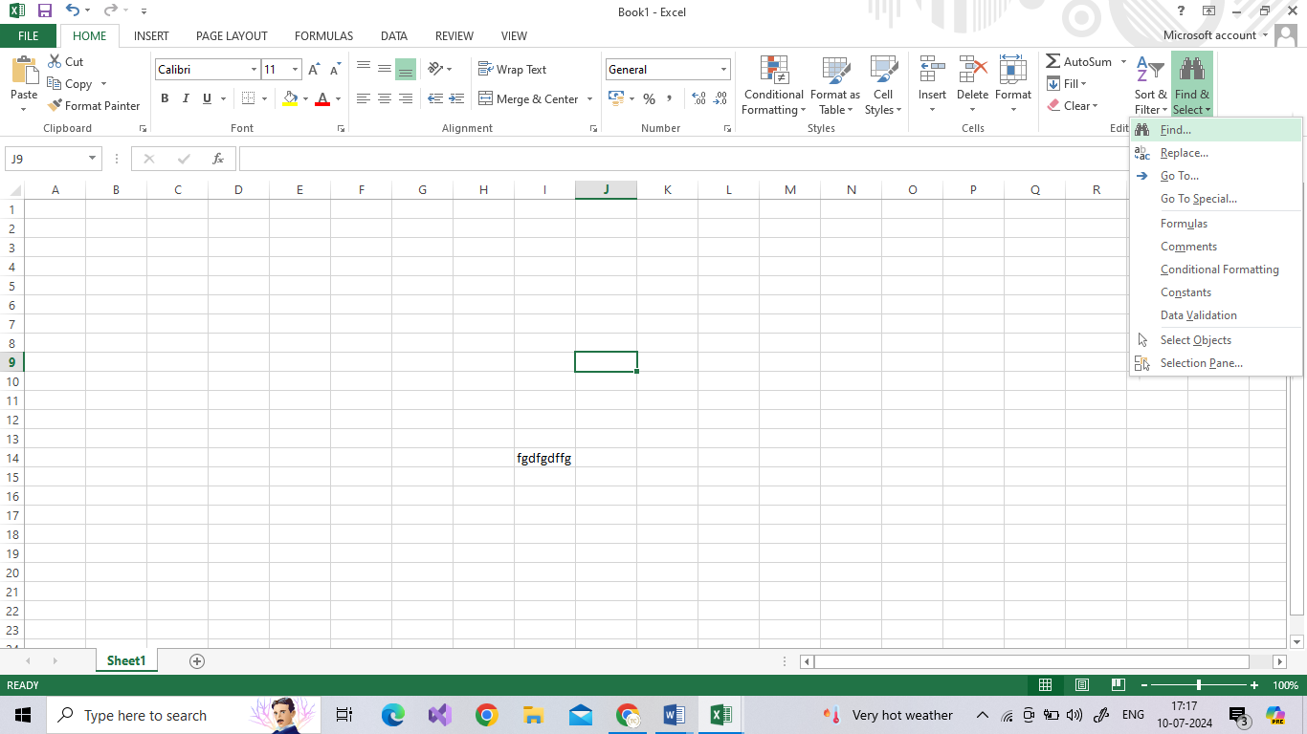

**Find**

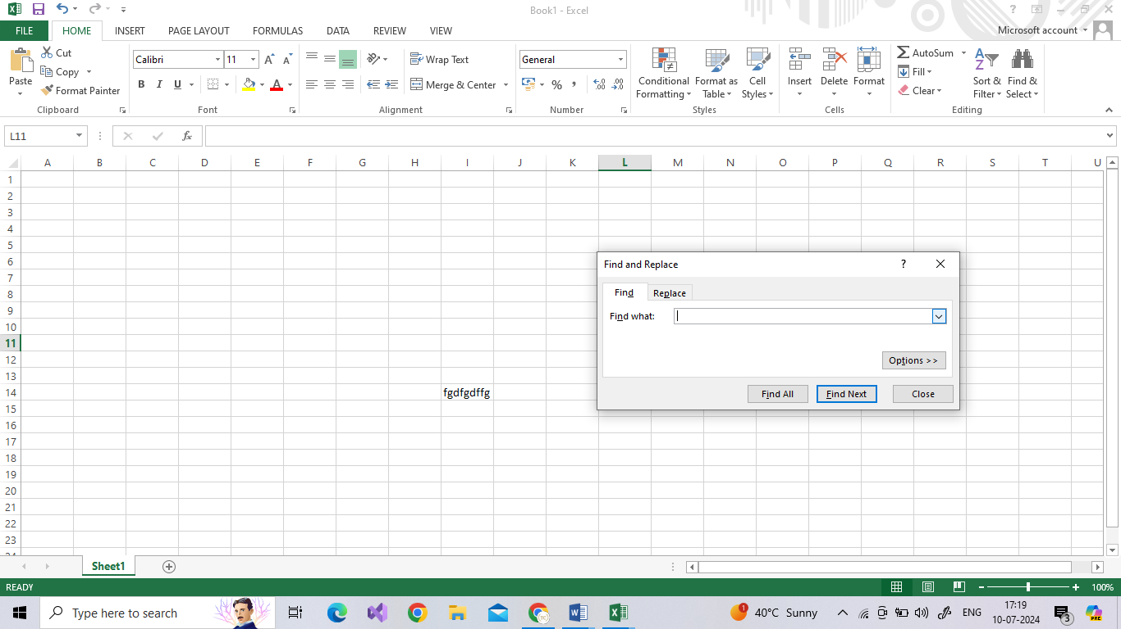To find something, press **Ctrl + F**, or go to **Home** > **Editing**> **Find & Select** > **Find**.

**Replace:**

To replace text or numbers, press Ctrl + H, or go to Home > Editing > Find & Select > Replace.

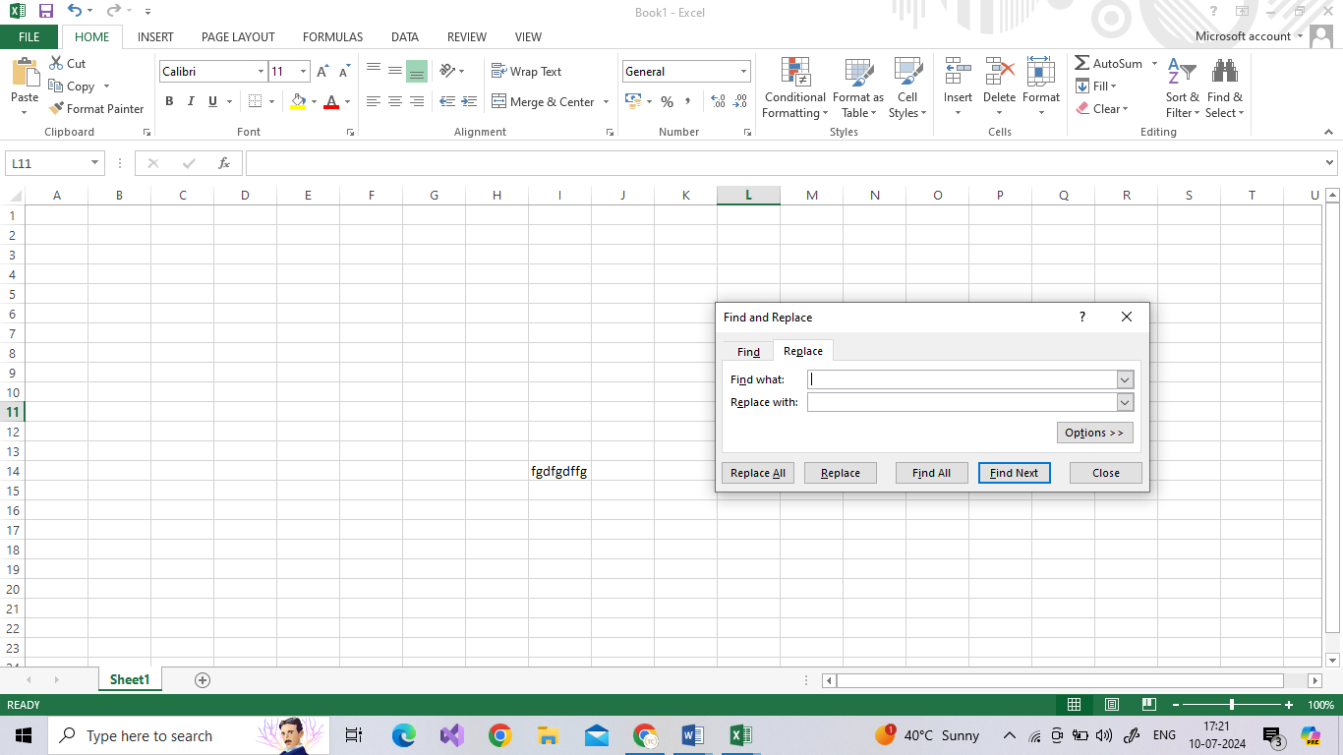

## CELL STYLES:

A cell style is a defined set of formatting characteristics, such as fonts and font sizes, number formats, cell borders, and cell shading.

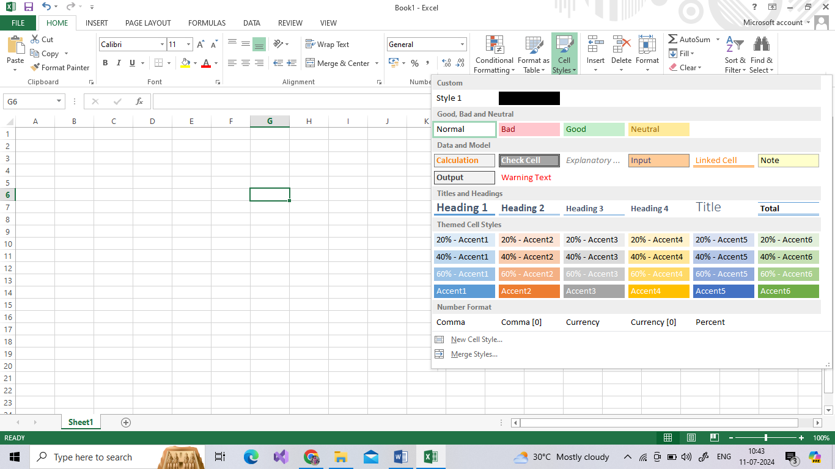

# **CHAPTER 3 FORMATTING NUMBERS**

In Excel, you can format numbers in cells for things like currency, percentages, decimals, dates, phone numbers, or social security numbers.

1. 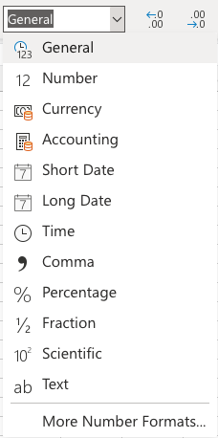Select a cell or a cell range.

On the **Home** tab, select **Number** from the drop-down.  
 Or

1. Press CTRL + 1 and select **Number**.

Or

1. Right-click the cell or cell range, select**Format Cells** and select **Number**.

Or

1. Select the small arrow, dialog box launcher, and then select **Number**.

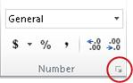

## Format Painter

Use Format Painter to quickly apply the same formatting, such as color, font style and size, or border style, to multiple pieces of text or graphics.

1. Select the text or graphic that has the formatting that you want to copy.
2. On the **Home** tab, select  Format Painter button**Format Painter** in the Clipboard group.

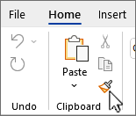

1. The cursor changes to a Shows format painter cursor with paintbrushpaintbrush icon.
2. Use the brush to *paint* over a selection of text or graphics to apply the formatting. This only works once. To change the format of multiple selections in your document, you must first double-click Format Painter button**Format Painter**.
3. To stop formatting, press **ESC**

# **CHAPTER 4-MANAGING WORKSHEET**

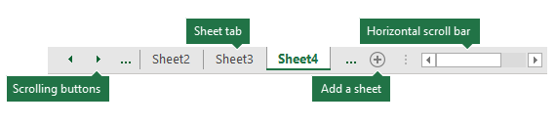

### Naming and Moving & Copying Worksheet

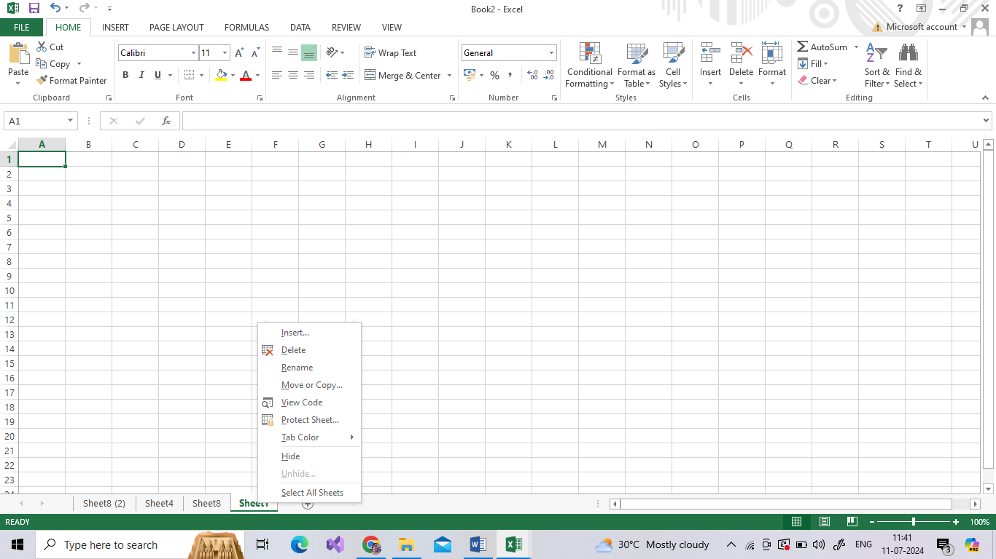

#### Rename a worksheet

1. Double-click the sheet tab, and type the new name.
2. Right-click the sheet tab, click Rename, and type the new name.

Image of Excel worksheet tabs

**Important:**  Worksheet names cannot:

* Be blank
* Contain more than 31 characters.
* Contain any of the following characters: / \ ? * : [ ]
* For example, 02/17/2016 would not be a valid worksheet name, but 02-17-2016 would work fine.
* Begin or end with an apostrophe ('), but they can be used in between text or numbers in a name.

#### Move a worksheet within a workbook

Select the worksheet tab, and drag it to where you want it.

#### Copy a worksheet in the same workbook

1. Press CTRL and drag the worksheet tab to the tab location you want.

OR

1. Right-click the worksheet tab and select **Move or Copy.**
2. Select the **Create a copy** checkbox.
3. Under**Before sheet**, select where you want to place the copy.
4. Select **OK**

#### Adding, Deleting and Hiding Worksheets

**Adding a worksheet**

* Select the New Sheet plus icon Select at the bottom of the workbook.
* Or, select Home > Insert > Insert Sheet.

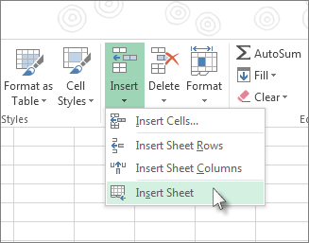

**Delete a worksheet**

1. Right-click the Sheet tab and select DeleteDelete.
2. Or, select the sheet, and then select Home > Delete > Delete Sheet.

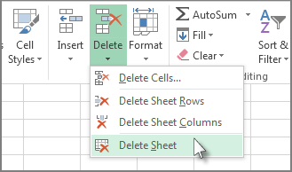

**Hide or Unhide worksheets**

1. Right-click the sheet tab you want to hide, or any visible sheet if you want to unhide sheets.
2. On the menu that appears, do one of the following:
3. To hide the sheet, select **Hide**.
4. To unhide hidden sheets, select them in the Unhide dialog that appears, and then select **OK**.

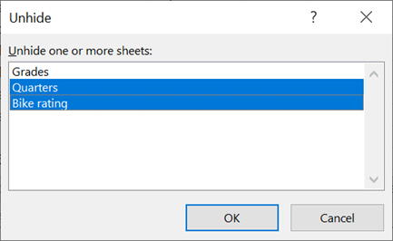

### Grouping Worksheets

In the example below, a workbook has multiple worksheets for different cities. All the worksheets have identical structures showing sales of coffee drinks.

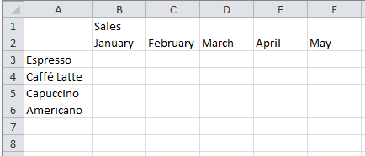

To perform the same tasks for a particular set of worksheets, follow the steps below.

1. Press and hold down the Ctrl key, and click the worksheet tabs you want to group.

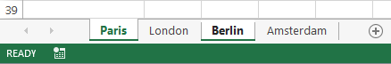

Tip: If you want to group consecutive worksheets, click the first worksheet tab in the range, press and hold the Shift key, and click the last worksheet tab in the range.

2.Now, suppose you want to add the same formula to cell B7 on both the “Paris” and “London” worksheets. When grouped, the change will happen on both worksheets when either worksheet is modified. For example, a formula change to the Paris worksheet is automatically made to the London worksheet:

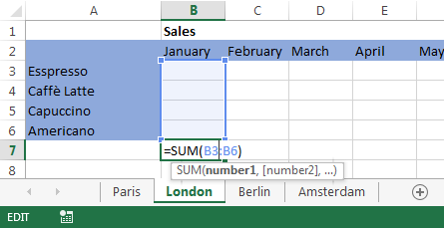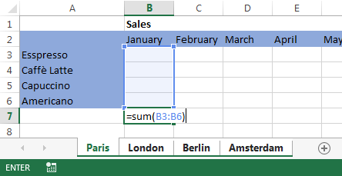

Note: When you group worksheets, the name of the workbook changes to include [Group**]**.

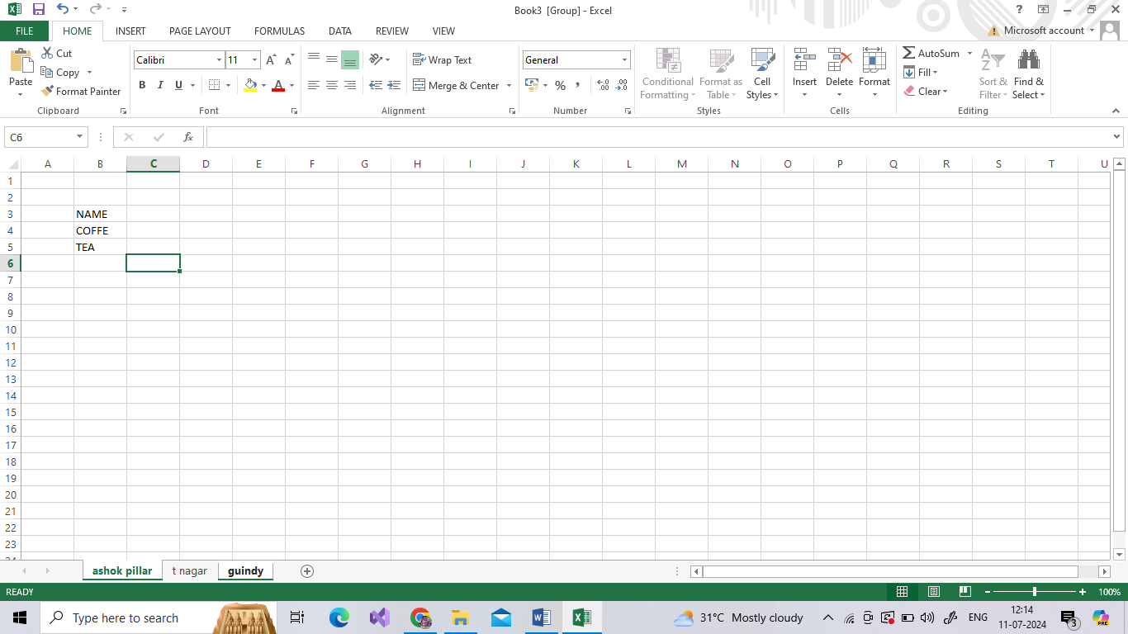

#### Ungroup selected worksheets

* Press and hold the Ctrl key, and click the worksheet tabs you want to ungroup.

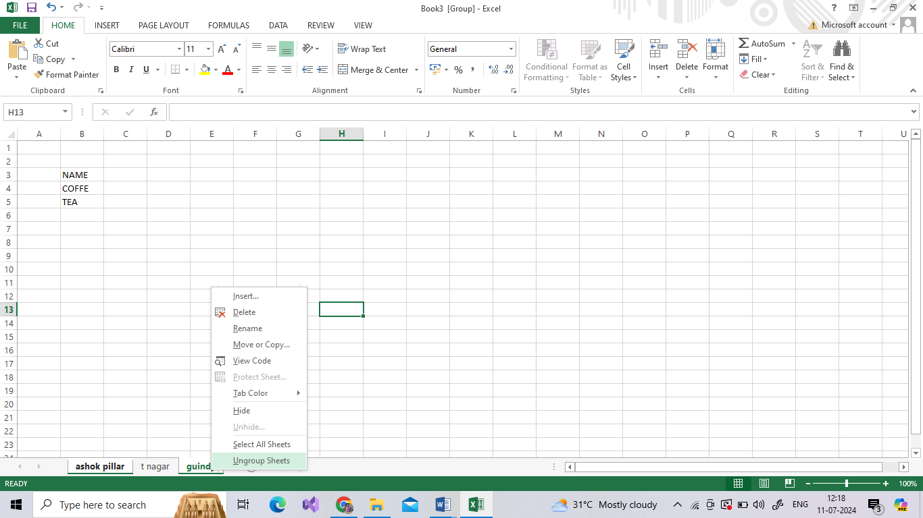

#### Group all worksheets

You can easily group all the worksheets in a workbook.

* Right-click any worksheet tab.
* Click **Select All Sheets**.

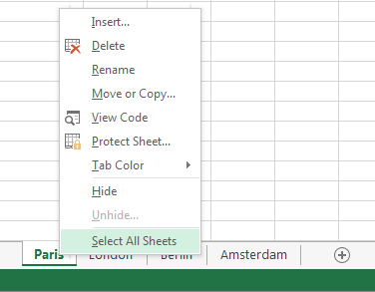

## FEATURES IN HOME TAB:

### Formatting Fonts

* Select the text you want to format.
* Click the **Bold**, **Italic**, or **Underline** buttons on the Home tab.

OR

* To bold, press **Ctrl** + **B**.
* To italicize, press **Ctrl** + **I**.
* To underline, press **Ctrl** + **U**.

### Change Font Color:

1. Select the cells you want to format.
2. Click the **Font Color** list arrow.
3. When text is selected in a cell, you can also click the **Font Color** list arrow on the Mini Toolbar.
4. 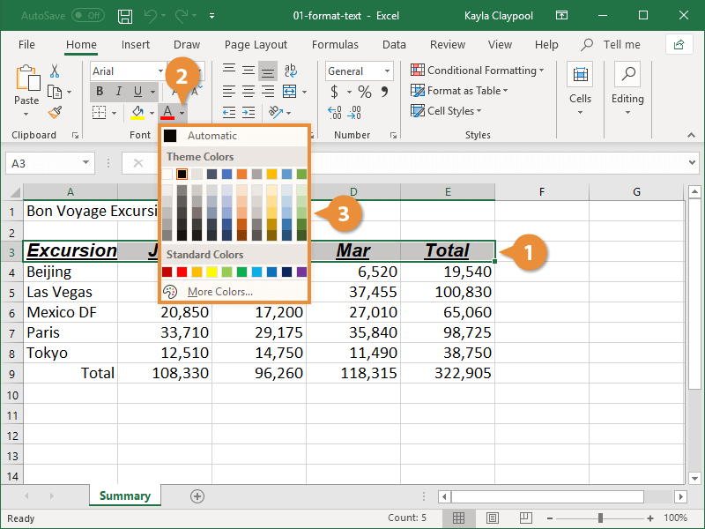Select a new color.

### Borders on a worksheet

**Applying a cell border**

On the **Home** tab, in the **Font** group, do one of the following:

* To apply a new or different border style, click the arrow next to **Borders** Button image, and then click a border style.
* To remove cell borders, click the arrow next to **Borders** Button image, and then click **No Border** Button image

**Remove a cell border**

1. On the **Home** tab, in the **Font** group, click the arrow next to **Borders** Button image, and then click **No Border** Button image.

--OR--

2. Click **Home** > the **Borders** arrow > **Erase Border**, and then select the cells with the border you want to erase.

### CREATE A CUSTOM CELL BORDER STYLE

1. On the **Home** tab, in the **Styles** group, click **Cell Styles**.
2. Click **New Cell Style**.
3. In the **Style name** box, type an appropriate name for the new cell style.
4. Click **Format**.
5. On the **Border** tab, under **Line**, in the **Style** box, click the line style that you want to use for the border.
6. In the **Color** box, select the color that you want to use.
7. Under **Border**, click the border buttons to create the border that you want to use.
8. 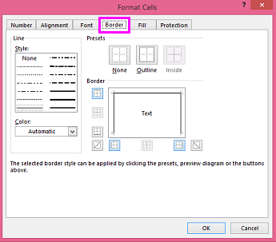Click **OK**.

**To apply the cell style, do the following**:

1. [Select the cells](https://support.microsoft.com/en-us/office/select-cell-contents-in-excel-23f64223-2b6b-453a-8688-248355f10fa9) that you want to format with the custom cell border.
2. On the **Home** tab, in the **Styles** group, click **Cell Styles**.
3. Click the custom cell style that you just created. Like the **FancyBorderStyle** button in this picture

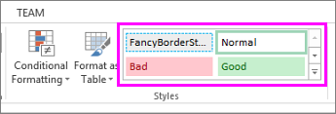

### Draw cell border

1. Click **Home** > the **Borders** arrow Borders button on the Home tab.
2. Pick **Draw Borders** for outer borders or **Draw Border Grid** for gridlines.

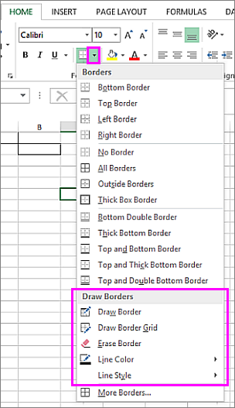

1. Click the **Borders** arrow > **Line Color** arrow, and then pick a color.
2. Click the **Borders** arrow > **Line Style** arrow, and then pick a line style.
3. Select cells you want to draw borders around.

### Wrap text

1. In a worksheet, select the cells that you want to format.
2. On the **Home** tab, in the **Alignment** group, select **Wrap Text**. (On Excel for desktop, you can also select the cell, and then press **Alt + H + W**.)

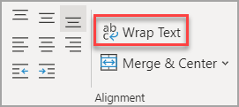

### Merge and unmerge cells

**Merge cells**

Select the cells to merge.

Select **Merge & Center.**

**Unmerge cells**

Select the **Merge & Center** down arrow.

Select **Unmerge Cells.**

# CHAPTER 5 – MODIFYING ROWS & COLUMNS

### INSERTING & DELETING A ROW AND COLUMN

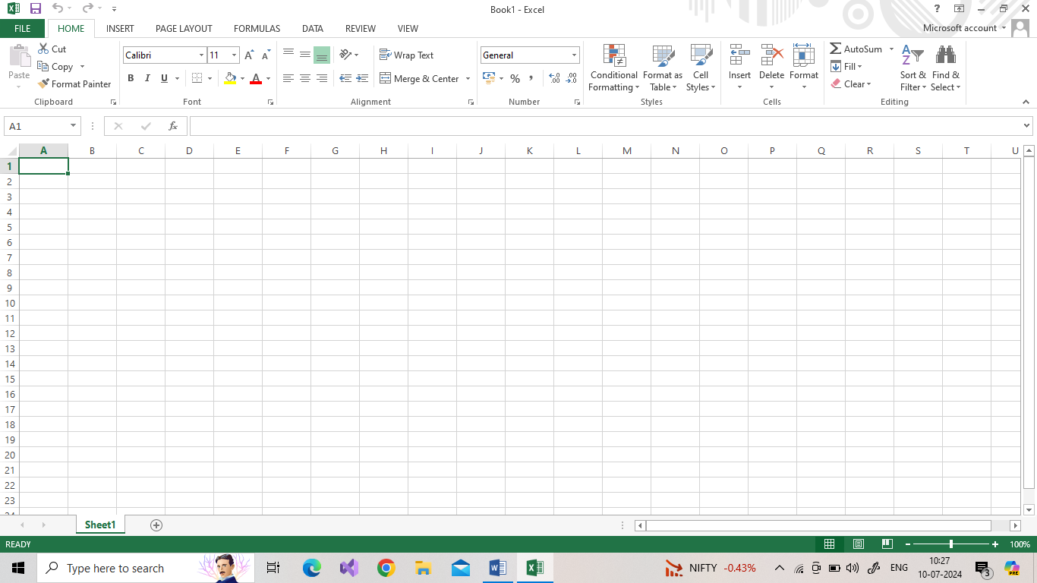

1. Select any cell within the column, then go to **Home** > **Insert** > **Insert Sheet Columns**or **Delete Sheet Columns**.

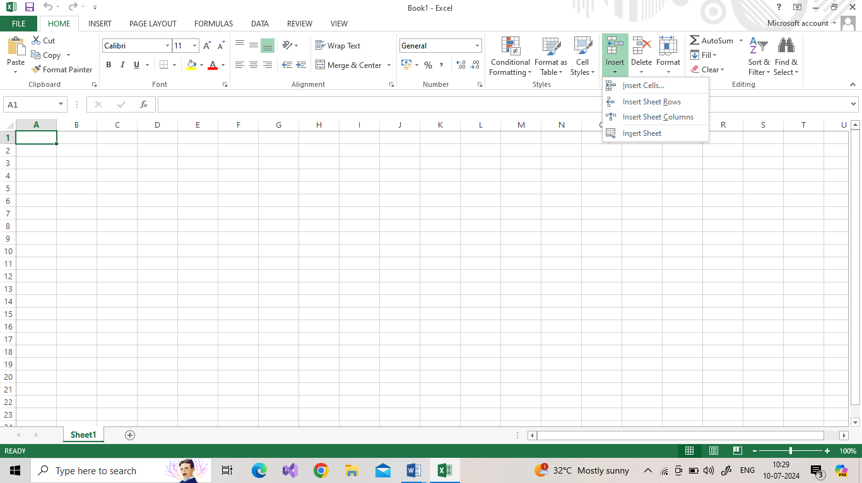

1. 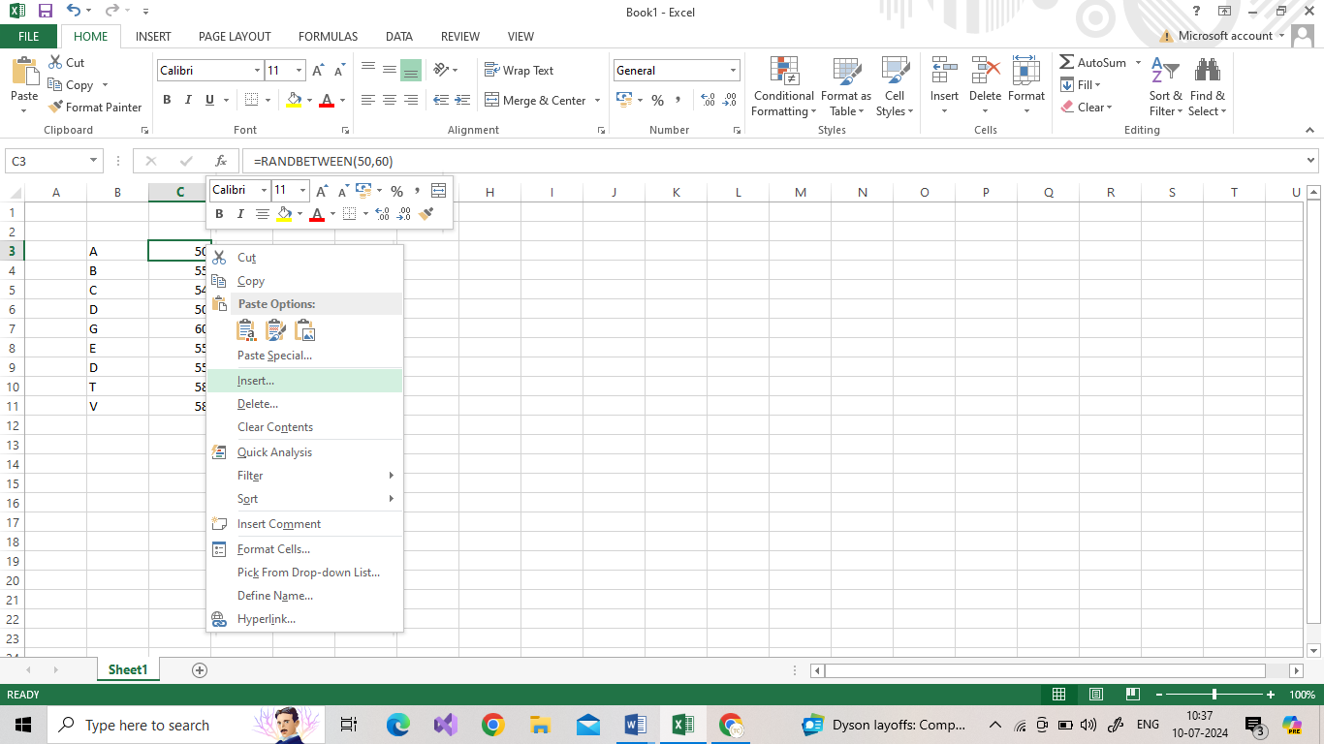Alternatively, right-click the top of the column, and then select **Insert** or **Delete**.
2. SELECT the entire column or row where you want to insert a new row or column and PRESS **Ctrl + “+”**

### CHANGING AND RESIZING THE WIDTH & HEIGHT

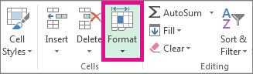

### Set a column to a specific width:

1. Select the column or Rows that you want to change.
2. Go to **Home** > **Cells** > **Format**.
3. Under **Cell Size**, select **Column Width**/ **Row height**
4. In the **Column width** **/ Row height** box, type the value that you want.
5. Select **OK**.

### Change the column width to automatically fit the contents:

1. Select the columns or Rows that you want to change.
2. Go to **Home** > **Cells** > **Format**.
3. Under **Cell Size**, select **AutoFit Column Width**/ **AutoFit Row Height**

### Change the width of the column by using mouse:

To change the width of one column, drag the boundary on the right side of the column heading until the column is the width that you want.

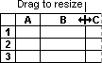

### Hiding and Unhiding Rows and Columns

1. On the **Home** tab, in the **Cells** group, click **Format**.

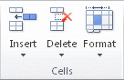

1. Do one of the following:

* Under**Visibility**, click**Hide & Unhide**, and then click **Unhide Rows** or **Unhide Columns**.

# **CHAPTER 6: UNDERSTANDING FORMULAS**

### Create a simple formula in Excel

1. On the worksheet, select the cell in which you want to enter the formula.
2. Type the **=** (equal sign) followed by the constants and operators (up to 8192 characters) that you want to use in the calculation.
3. For our example, type **=1+1**.
4. Press **Enter** (Windows)

### Use AutoSum

**AutoSum** is in two locations: **Home** > **AutoSum**, and **Formulas** > **AutoSum**.

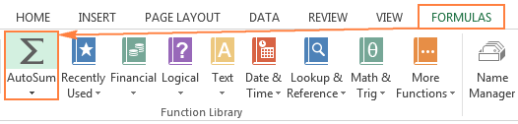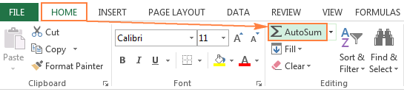

FORMULAS:

=SUM (num1,num2….N)

=MAX (num1,num2…N)

=MIN (num1,num2…..N)

=AVERAGE (num1,num2…N)

=COUNT (num1,num2…N)

### How to copy formula down a column

1. Enter a formula in the top cell.
2. Select the cell with the formula, and hover the mouse cursor over a small square at the lower right-hand corner of the cell, which is called the **Fill handle**. As you do this, the cursor will change to a thick black cross.
3. Hold and drag the fill handle down the column over the cells where you want to copy the formula.

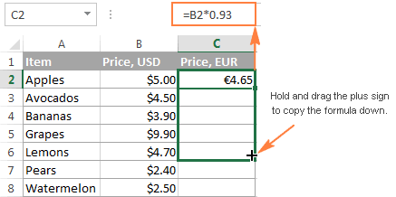

### Cell References

A cell reference refers to a cell or a range of cells on a worksheet and can be used in a formula so that Microsoft Office Excel can find the values or data that you want that formula to calculate.

Type the = (equals) sign, followed by a reference to a cell

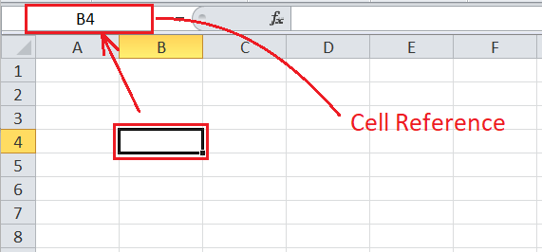

# CHAPTER 7: CHANGING VIEWS

### Workbook Views

**Excel** offers three different workbook views: **Normal**, **Page Layout** and **Page Break Preview**.

Normal

At any time, you can switch back to Normal view.

1. On the View tab, in the Workbook Views group, click Normal.

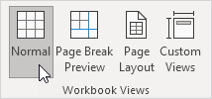

Page Break Preview

Page Break Preview gives you a nice overview of where pages break when you print the document. Use this view to easily click and drag [page breaks](https://www.excel-easy.com/examples/page-breaks.html).

1. On the View tab, in the Workbook Views group, click Page Break Preview.

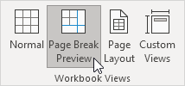

Page Layout

Use Page Layout view to see where pages begin and end, and to add [headers and footers](https://www.excel-easy.com/examples/headers-footers.html).

1. On the View tab, in the Workbook Views group, click Page Layout.

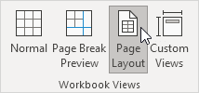

### Zoom Features

1. On the status bar of your Office app, click the zoom slider.

Zoom slider

1. Slide to the percentage zoom setting that you want. Click **–** or **+** to zoom in gradual increments.

### Freeze Panes

Freeze rows or columns

* Freeze the first column

Select View > Freeze Panes > Freeze First Column.

            The faint line that appears between Column A and B shows that the first column is frozen.

* Freeze the first two columns

Select the third column.

Select View > Freeze Panes > Freeze Panes.

* Freeze columns and rows

Select the cell below the rows and to the right of the columns you want to keep visible when you scroll.

Select View > Freeze Panes > Freeze Panes.

**Unfreeze rows or columns**

On the View tab > Window > Unfreeze Panes.

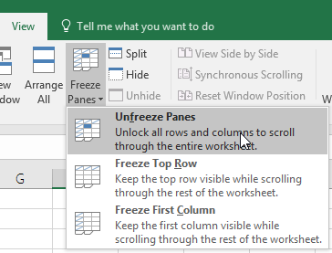

### Split a sheet into panes

* You can view two areas of a sheet by splitting it into pane. When you split a sheet into separate panes, you can scroll in both panes independently.
* Select below the row where you want the split, or the column to the right of where you want the split.
* On the **View** tab, in the **Window** group, click **Split**.
* To remove the split panes, click **Split** again.

### View multiple sheets in one workbook

1. Open the workbook that you want to view.
2. On the **Window** menu, click **New Window**.
3. Switch to the new window, and then click the tab for the sheet that you want to view.
4. Repeat steps 2 and 3 for each sheet that you want to view.
5. On the **Window** menu, click **Arrange**.

### View multiple workbooks

1. Open all the workbooks that you want to view.
2. On the **Window** menu, click **Arrange**.

### Minimize The Ribbon

1. At the top-right corner, select the **Ribbon Display Options** icon Ribbon icon.

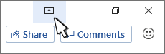

Choose an option for the ribbon:

1. **Show Tabs and Commands** keeps all the tabs and commands on the ribbon visible all the time.

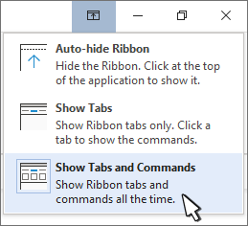

# CHAPTER 8 AUTOFILL AND CUSTOM LISTS

**Autofill**

Excel has a feature that helps you automatically enter data. If you are entering a predictable series (e.g. 1, 2, 3…; days of the week; hours of the day) you can use the AutoFill command to automatically extend the sequence.





* copy cells,
* fill series,
* fill formatting only,
* fill without formatting, and,
* flash fill.

### AutoFill Non-Adjacent Cells

Non-adjacent cells are cells that aren't directly in contact with one another

To select non-adjacent cells and cell ranges, hold Ctrl and select the cells.

### Creating Custom Lists

1. Select the columns to sort.
2. 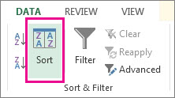In the ribbon, click **Data** > **Sort**.
3. In the **Sort** popup window, in the **Sort by** drop-down, choose the column on which you need to sort.
4. From the **Order** drop-down, select **Custom List**.
5. In the **Custom Lists** box, select the list that you want, and then click **OK** to sort the worksheet.

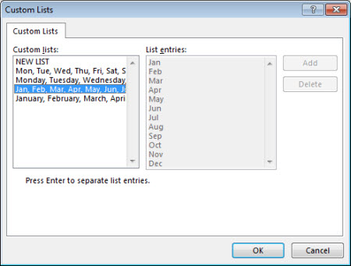

### Create your own custom list

Follow these steps to create your own custom list for sorting:

1. In a column of a worksheet, type the values to sort by. Arrange them in the order that you want to define the sort order—from top to bottom. For example:

* High
* Low
* medium

1. Select all of the cells in that list, and then click **File** > **Options** > **Advanced**.
2. Scroll way down to the **General** section and click **Edit Custom Lists**...

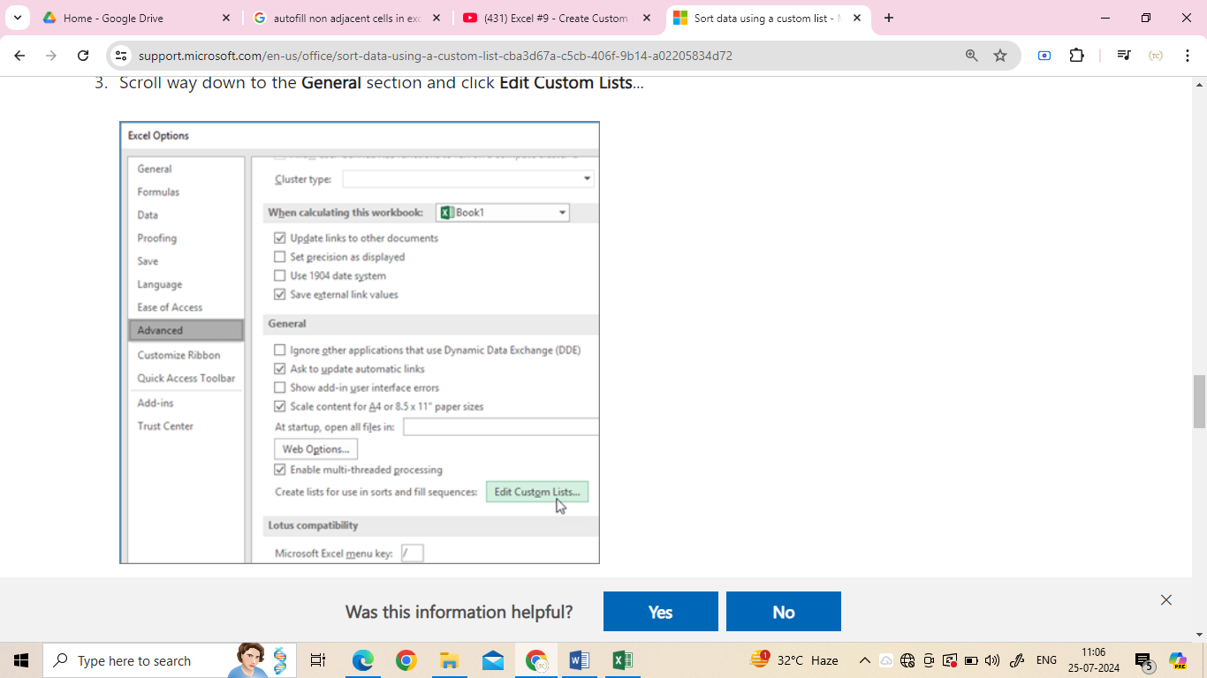

1. In the **Custom Lists** box, click **Import**.

### Series Formatting

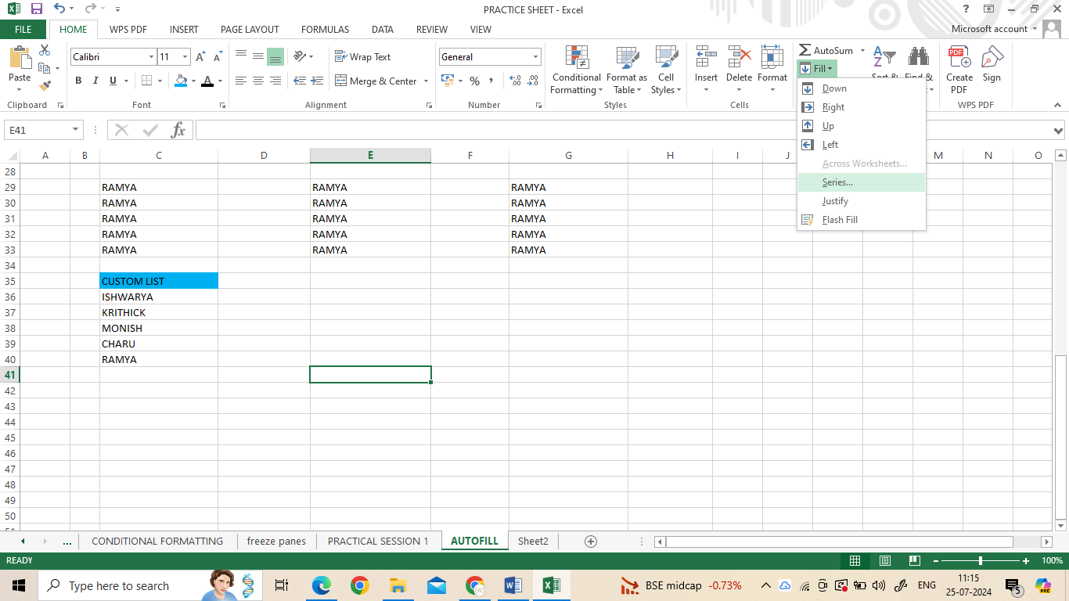

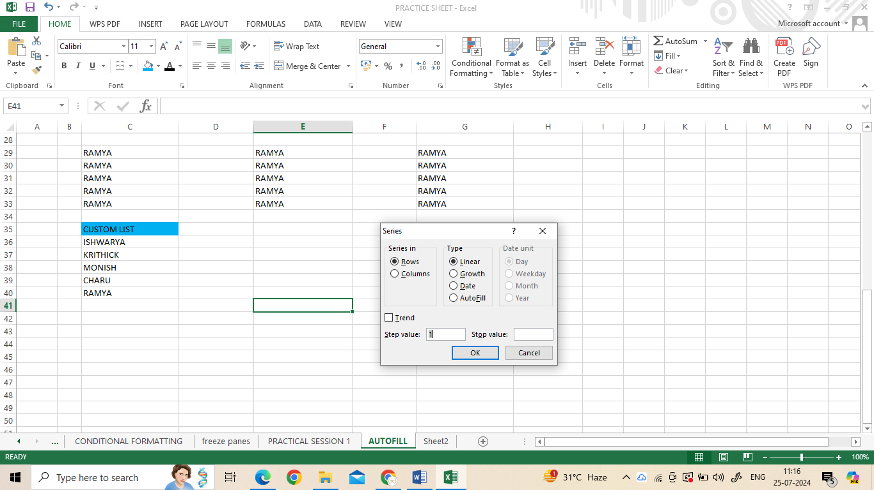

# CHAPTER 9 CONDITIONAL FORMATTING

### Conditional Formatting

Conditional formatting is used to change the appearance of cells in a range based on your specified **conditions**.

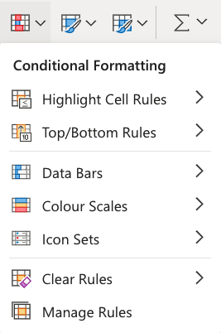The conditions are rules based on specified numerical values or matching text.

Conditional formatting, step by step:

1. Select the range of Speed values C2:C9
2. Click on the Conditional Formatting icon https://www.w3schools.com/excel/img_excel_cf_icon.png in the ribbon, from the **Home** menu
3. Select **Color Scales** from the drop-down menu
4. Click on the "Green - Yellow - Red Colour Scale" icon

Dark green is used for the highest values, and dark red for the lowest values.

### Highlight Cell Rules

Highlight Cell Rules is a premade type of conditional formatting in Excel used to change the appearance of cells in a range based on your specified **conditions**.

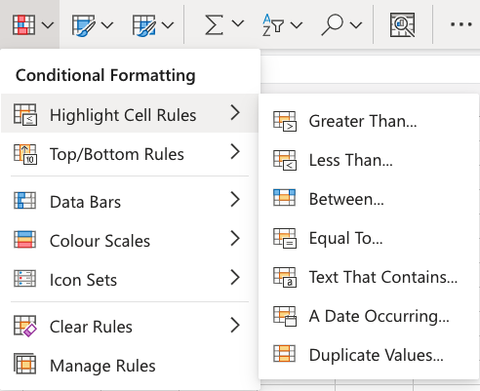The conditions are rules based on specified numerical values, matching text, calendar dates, or duplicated and unique values.

### Appearance Options

The web browser version of Excel offers the following appearance options for conditionally formatted cells:

* Light Red Fill with Dark Red Text
* Yellow Fill with Dark Yellow Text
* Green Fill with Dark Green Text
* Light Red Fill
* Red Text
* Red Border

### Excel Top/Bottom Rules

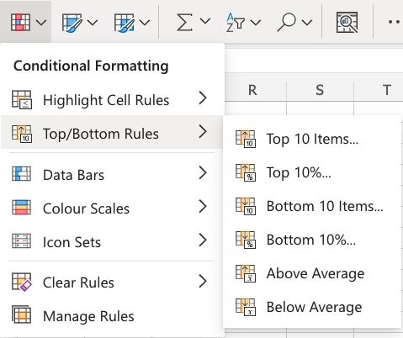Top/Bottom Rules are premade types of conditional formatting in Excel used to change the appearance of cells in a range based on your specified **conditions**.

**Above and Below**

**Average Rules**

Above and Below Average Rules are premade types of conditional formatting in Excel used to change the appearance of cells in a range based on your specified **conditions**.

Above and Below Average Rules are found in the **Top/Bottom Rules** part of the conditional formatting menu:



### Data Bars

Data Bars are premade types of conditional formatting in Excel used to add colored bars to cells in a range to indicate how large the cell values are compared to the other values.

Here is the Data Bars part of the conditional formatting menu:

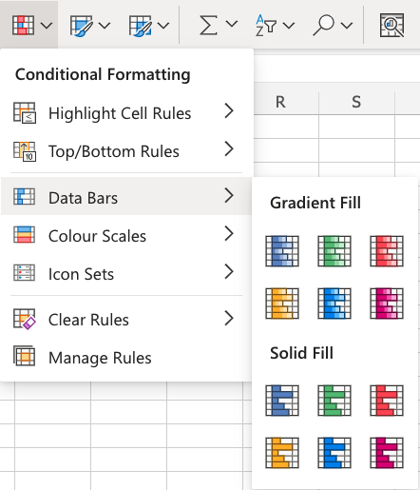

Icon Sets

## Options

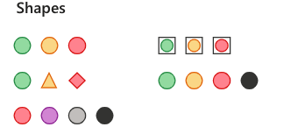Excel has a number of different icon sets, organized as:

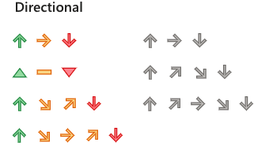

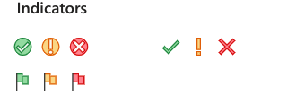

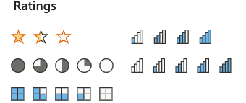

## Create a Custom Conditional Formatting Rule

1. Select the range you want to format.
2. Click the **Conditional Formatting** button on the Home tab.
3. Select **New Rule**.

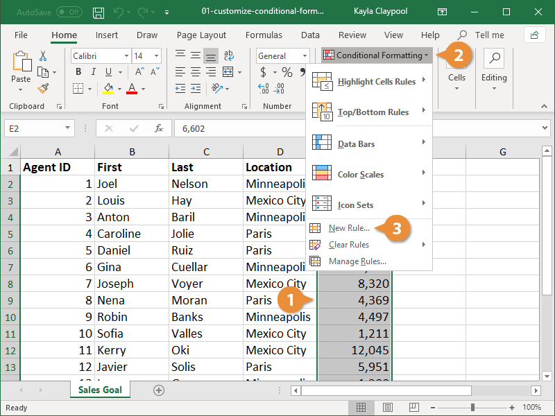

1. Select a Rule Type.
2. The area below will display different fields depending on the type of rule you selected.
3. Edit the styles and values.
4. A preview appears at the bottom of the dialog box, so you can get a glimpse of the formatting before applying the new rule.
5. Click the **OK**.

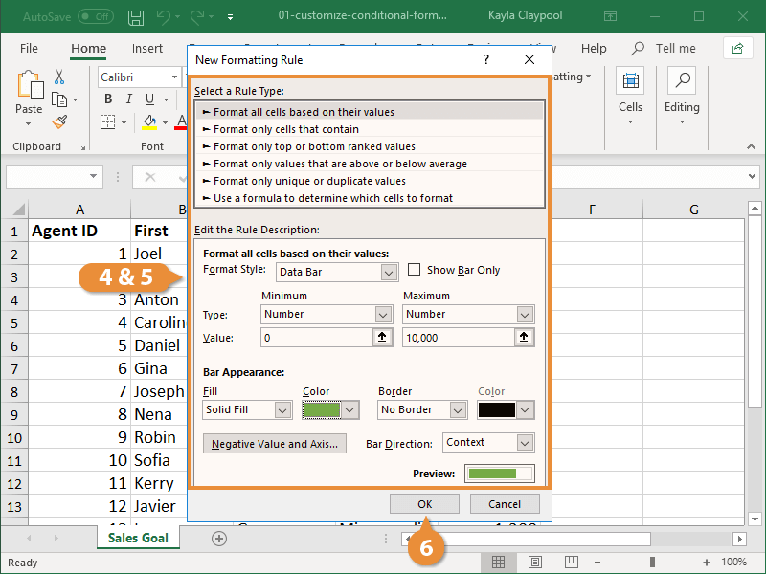

# CHAPTER 10: TABLES

Tables make it easier to structure and organize data.

Tables can be used to prepare data for charts and pivot tables.

Tables allow for options such as:

* Sort & Filter
* Formatting
* AutoFilling

## Converting a Range to Table

* 1. Select range A1:F22
  2. Click **Insert**, then Table (https://www.w3schools.com/excel/img_excel_table_menu.png), in the Ribbon.

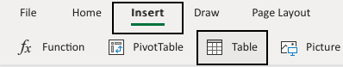

3. Click OK

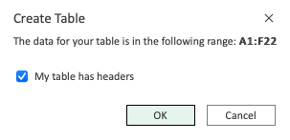



The range A1:F22 was successfully converted from range to table.

## Table Design

Tables can be customized and styled in a few clicks.

Converting a range into a table gives access to a menu called "Table Design".



This menu has options and commands such as:

* Resize
* Remove duplicates
* Convert to range
* Style options (Total row, Header row, Banded row etc..)
* Formatting

### Table Name

The name of the table can be found in the Table Design tab

1. Select the table
2. Click the Table design menu
3. See the name input field



### Table Resizing

The size of a table can be changed.

Resizing is to increase or decrease the range of the table.

There are three ways to resize a table

* Resize table command
* Drag to resize
* Adding headers

### Resize Table Command

The command is found in the Ribbon under the Table Design tab.



The header name can be changed.

1. Double click G1
2. Delete the text
3. Type "Mighty" to G1

### Removing Duplicates

Excel has a command to remove duplicates in tables.

**Note:** Duplicates are extra copies of values.

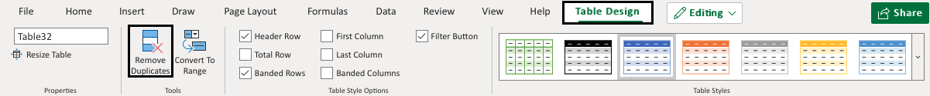

Convert the range into a table.

1. Select the table
2. Click the Table Design tab (https://www.w3schools.com/excel/img_excel_tables_27.png)
3. Click the Remove Duplicates command (https://www.w3schools.com/excel/img_excel_tables_28.png)
4. Leave all columns checked
5. Click OK

## Converting a Table to Range

Tables can be reversed and converted back to range.

Tables can be converted to ranges by selecting a cell in the table range and clicking on the Convert to Range command.

The command to convert to range is found in the Table Design tab, in the Tools group.

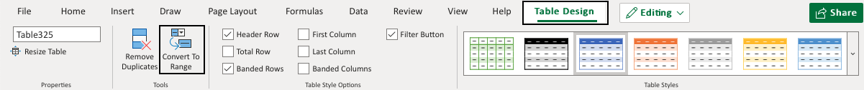

Convert the range into a table.

1. Select a cell in the table range
2. Click the Design Table tab (https://www.w3schools.com/excel/img_excel_tables_27.png)
3. Click the Convert to Range command (https://www.w3schools.com/excel/img_excel_tables_35.png)

## Table Style

Excel has many ready to use styles which can be applied for tables.

Table styles is to change the appearance of the table.

It can be changed to:

* Make it easier to read and understand
* Make it look better

The table style is **Blue, Table Style Medium 2** by default.

Excel has three main categories for Table styles:

* Light; Light colors, more white space
* Medium; Medium colors, medium white space
* Dark; Dark colors, less white space

Convert the range into a table.

1. Select a cell in the table range
2. Click the Design Table tab (https://www.w3schools.com/excel/img_excel_tables_27.png)
3. Click on the Table Styles option button

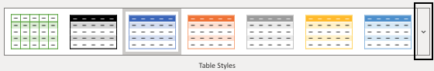

# CHAPTER 11: DATA TOOLS

Data validation in Excel is a feature that controls what can be entered into a cell or range of cells in a worksheet.

It can help reduce errors, unstandardized data, and irrelevant information.

Data validation can be applied to various types of data, including text, numbers, dates, and lists

Select the cell(s) you want to create a rule for.

1.Select **Data >Data Validation**.

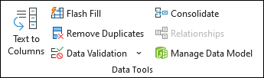

2.On the **Settings**tab, under **Allow**, select an option:

* **Whole Number**- to restrict the cell to accept only whole numbers.
* **Decimal**- to restrict the cell to accept only decimal numbers.
* **List**- to pick data from the drop-down list.
* **Date**- to restrict the cell to accept only date.
* **Time**- to restrict the cell to accept only time.
* **Text Length**- to restrict the length of the text.
* **Custom**– for custom formula.

Under **Data**, select a condition.

3.Set the other required values based on what you chose for **Allow**and **Data**.

4.Select the **Input Message**tab and customize a message users will see when entering data.

5.Select the **Show input message when cell is selected**checkbox to display the message when the user selects or hovers over the selected cell(s).

6.Select the **Error Alert**tab to customize the error message and to choose a **Style**.

7.Select **OK**.

Now, if the user tries to enter a value that is not valid, an **Error Alert**appears with your customized message.

## How to Create a Simple Drop-down List in Excel

* 1. Create a list of items you want to include in your drop-down.
  2. Go to the location where you want the list to appear, select all the cells.
  3. Go to **Data**(tab) > **Data Tools**(group) > **Data Validation**.
  4. For **Allow**select **List**.
  5. Click OK.

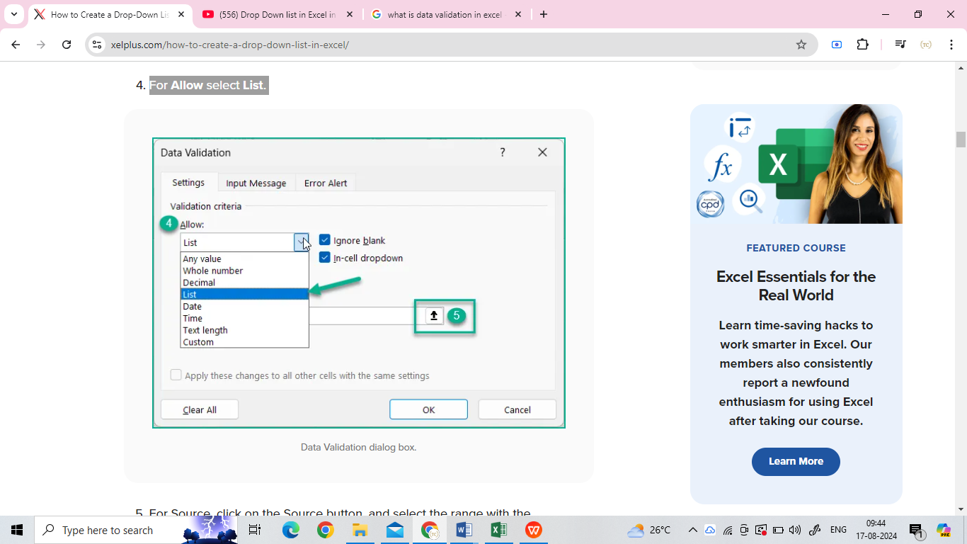

## Split text into different columns

1. Select the range with full names.

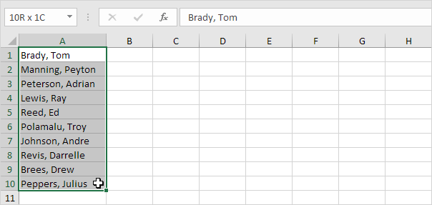

2. On the Data tab, in the Data Tools group, click Text to Columns.

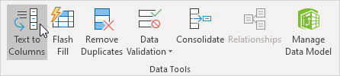

The following dialog box appears.

3. Choose Delimited and click Next.

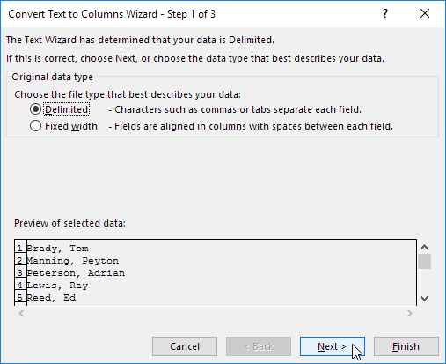

4. Clear all the check boxes under Delimiters except for the Comma and Space check box.

5. Click Finish.

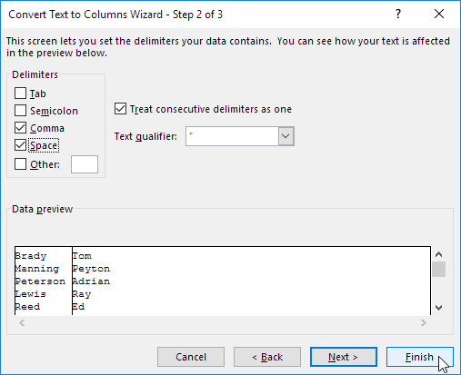

Note: This example has commas and spaces as delimiters. You may have other delimiters in your data. Experiment by checking and unchecking the different check boxes. You get a live preview of how your data will be separated.

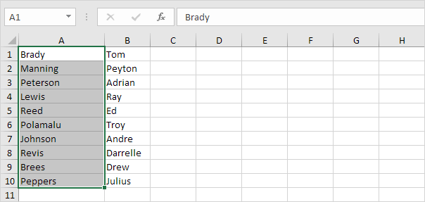Result:

# CHAPTER 12- What-if Analysis

## Goal Seek

Goal Seek is a tool in Excel that helps you find a result by adjusting an input value.

### ****How to Use Goal Seek in Excel****

**Step 1:**Go to the Data Tab in MS Excel

**Step 2:** In the Data Tools group, you will find a What-if analysis

**Step 3:** Click on What if analysis, and you will find Goal Seek

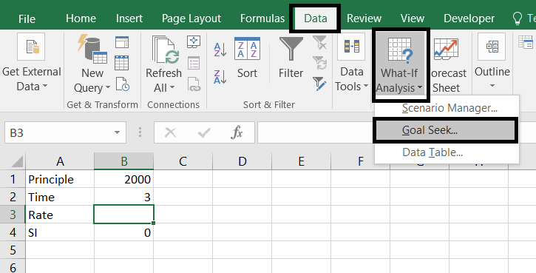

**Goal seek dialogue box has three parts:**

1. Set Cell: In this, we write the reference of the cell which contains the formula.
2. To value: In this, we write the value which we want to attain(or the given resultant value).
3. By changing Cell: In this, we write the reference of the cell whose value we want to change(i.e. the cell whose value is to be calculated).

### **Example**

1. Determine the Value of the unit if the **Sum** is given. We have to calculate the value, when the Sum of the values is 303.

**Step 1:** Enter the values in the Cells

**Step 2:**Write the Formula of **SUM()** in any Cell

**Step 3: Click Data tab and Go to What-if Analysis and Select Goal Seek**

Now click on the **Data tab** in the Ribbon, and select the option **What-if-analysis** to open**Goal Seek.**

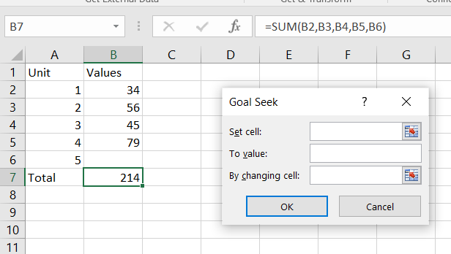

**Step 4:** Select the cell which contains the formula

In the Set cell Box, Select the cell which contains the formula.

**Step 5:** Write the Resultant value of total, 303 (given)

In the To value box, Write the Resultant value of total, 303 (given).

**Step 6:** Write the Reference of the cell in Which you Want the Value

In the by-changing cell, Write the reference of the cell in which you want the value.

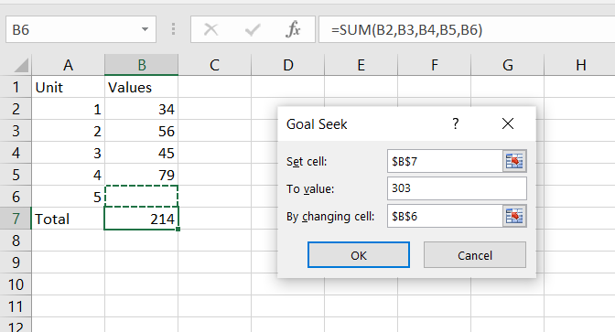

**Step 7:**Click **Ok**

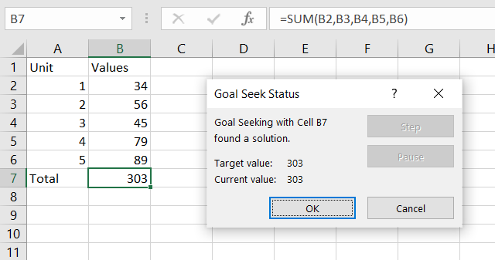

## Scenario Manager:

Excel's Scenario Manager is a tool that lets you create and save multiple versions of data in the same cell

### Use Scenario Manager

1. Select the cells that contain values that could change.
2. Click the **Data** tab on the ribbon.
3. Click the **What-If Analysis** button.
4. Select **Scenario Manager**.
5. The Scenario Manager dialog box appears with the message “No Scenarios defined. Choose Add to add scenarios.
6. Click the **Add** button to add a new scenario.
7. Type a name for the new scenario.
8. 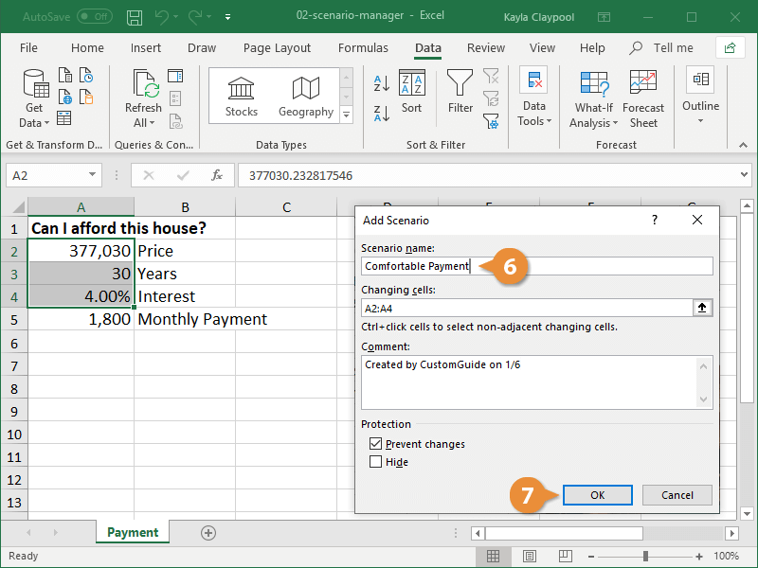Click **OK**.

### View a Scenario Summary

1. Click the **Data** tab.
2. Click the **What-If Analysis** button.
3. Select **Scenario Manager**.

The Scenario Manager dialog box appears, displaying all the scenarios you’ve created.

1. Click **Summary**
2. Click **OK**

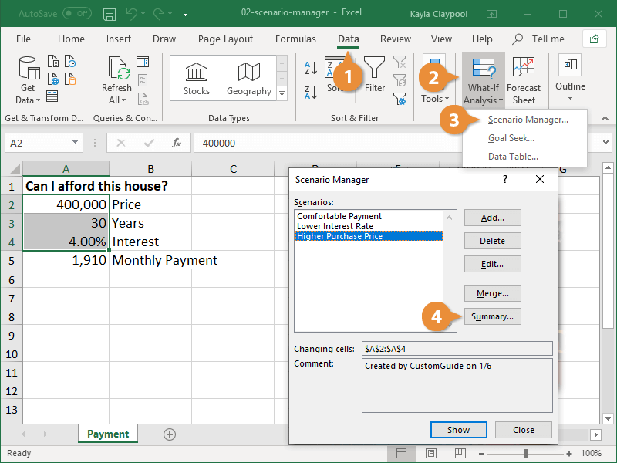

# CHAPTER 13: Referencing Formulas

## Consolidate data from multiple worksheets within the same workbook

We have three sheets in an Excel workbook containing three years of expenditure on tea, coffee, and cold drink (on a quarterly basis). All three sheets are named Year1, Year2, and Year3, respectively. Means that - each worksheet contains a year of data and it is broken down into quarters.

To consolidate the data within the same workbook, we can insert a new worksheet in the same workbook and name it as **Consolidate Summery.** This consolidated summery sheet will show the expenditure by year and quarter.

See our three of worksheets for year1, year2, and year3 with data is as follows -

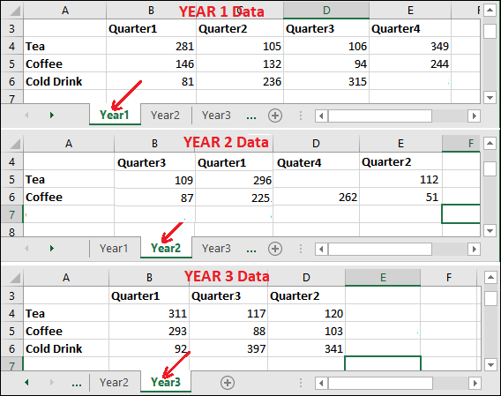

Steps to consolidate data

To consolidate the data, you must first to insert an empty worksheet to make it a master sheet to keep the data after consolidation.

**Step 1:** Insert a new worksheet within the same workbook. Renamed it as **Consolidate Summery** to make it easily recognizable.

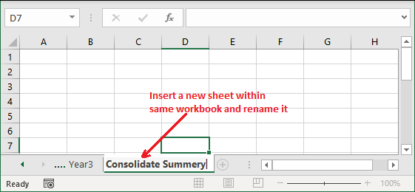

**Step 2:** Inside consolidate summery worksheet, select the first cell or any other where the consolidated data will appear.

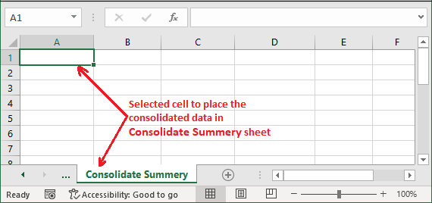

**Step 3:** Go to the **Data** tab in the Excel ribbon and click the **Consolidate** button inside the Data Tools section.

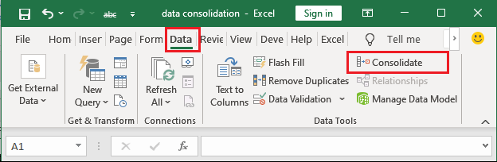

**Step 4:** A consolidate dialog box will open like below, provide the value and select the options you require.

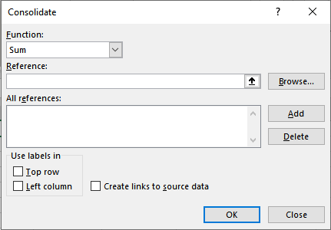

1. Select the function based on which you want to consolidate the data. E.g., **SUM.** You can select SUM inside the function dropdown list to consolidate data.

Consolidate data in Excel

2. In the Reference area, select the first data ranges of sheets one by one to consolidate.

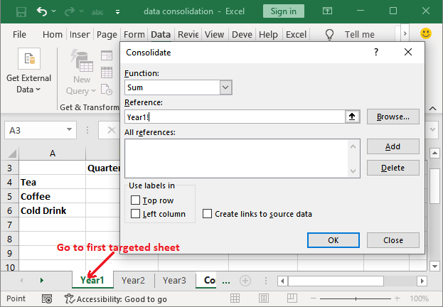a. Keep the cursor on the reference area and go to the targeted sheet, i.e., Year1, without closing the consolidate panel.

b. Now, select the range of data over here (including both headers) to add for consolidation.

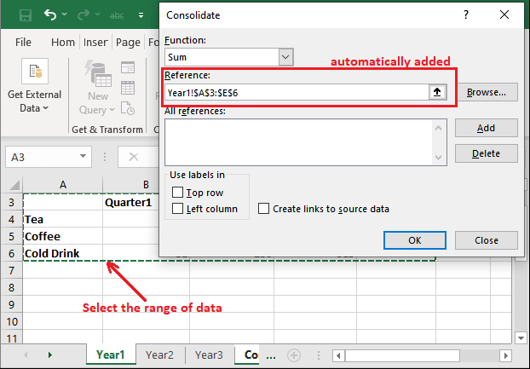

You will see that the selected range is automatically added to the reference field.

c. Now, click the **Add** button to add this first set of data to the **All References** area in consolidate dialog box.

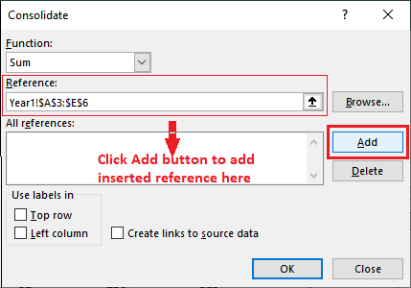

d. Now, navigate to the **Year2** worksheet and select the range as in the above steps. After that, click the **Add** button to move it into all references field.

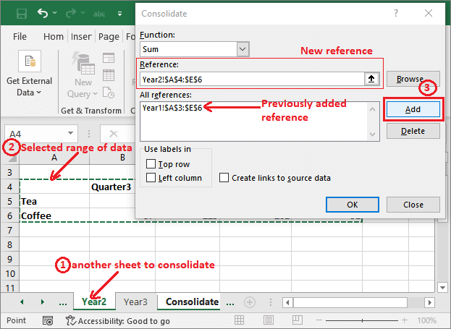

e. See that another reference is added here.

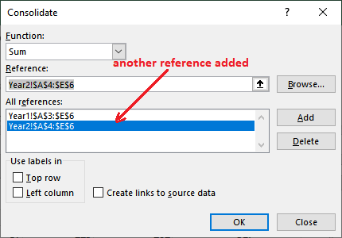

Continue the same process for other worksheets to add them in consolidate dialog.

f. See that all three of them sheets range of data is added to inside the References field. Now, click the **OK** button here.

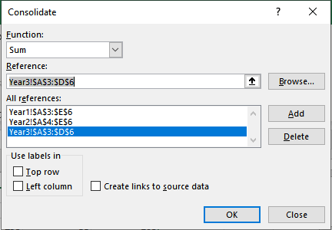

3. To indicate that where the labels are located in source ranges, consolidate has two checkboxes: **Top Row** and **Top Column.** Mark them accordingly.

4. Our data has a row header (Quater1, Quater2, Quater3, Quarter4) and column header (Tea, Milk, Coffee), so mark both checkboxes.

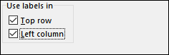

5. Mark the **Create links to source** checkbox if you want automatic update in the consolidate sheet on changing in source data.

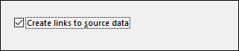

**Step 5:** When all settings are done, you can now click the **OK** button.

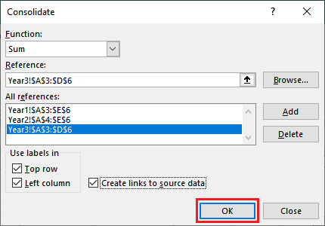

**Step 6:** Your data will be pasted inside the consolidate summery sheet (newly added sheet) within the same workbook.

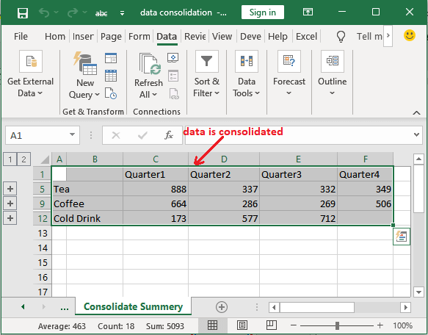

**Step 7:** On the left side of the Excel screen, you will find grouping tools **(+),** which you can use to expand and hide the data.

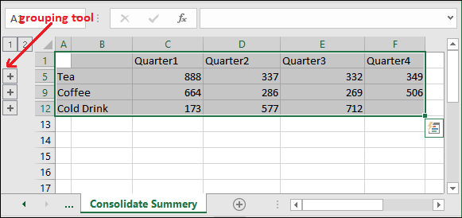

**Step 8:** Click the first grouping tool (+) to expand and see how the consolidated result is calculated for the **Tea** row.

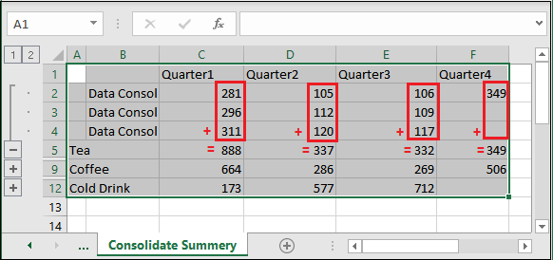

For tea row -

**Quarter1:** 281+296+311 = 888

**Quarter2:** 105+112+120 = 337

**Quarter3:** 106+109+117 = 332

**Quarter4:** 349 = 349

## Trace Precedents & Dependents in Excel

**How to Trace Precedents in Excel**

1. Select the cell you want to trace precedents for.
2. Go to the “Formula Auditing” group on the “Formulas” tab.
3. Click on the “Trace Precedents” button ( or Ctrl + ] ). Excel will draw arrows to show the cells that are used in the calculation of the selected cell.
4. If the cell has multiple precedents, you can use the “Trace Precedents” button again to trace the precedents of the precedent cells.
5. To remove the arrows, click on the “Remove Arrows” button in the “Formula Auditing” group.

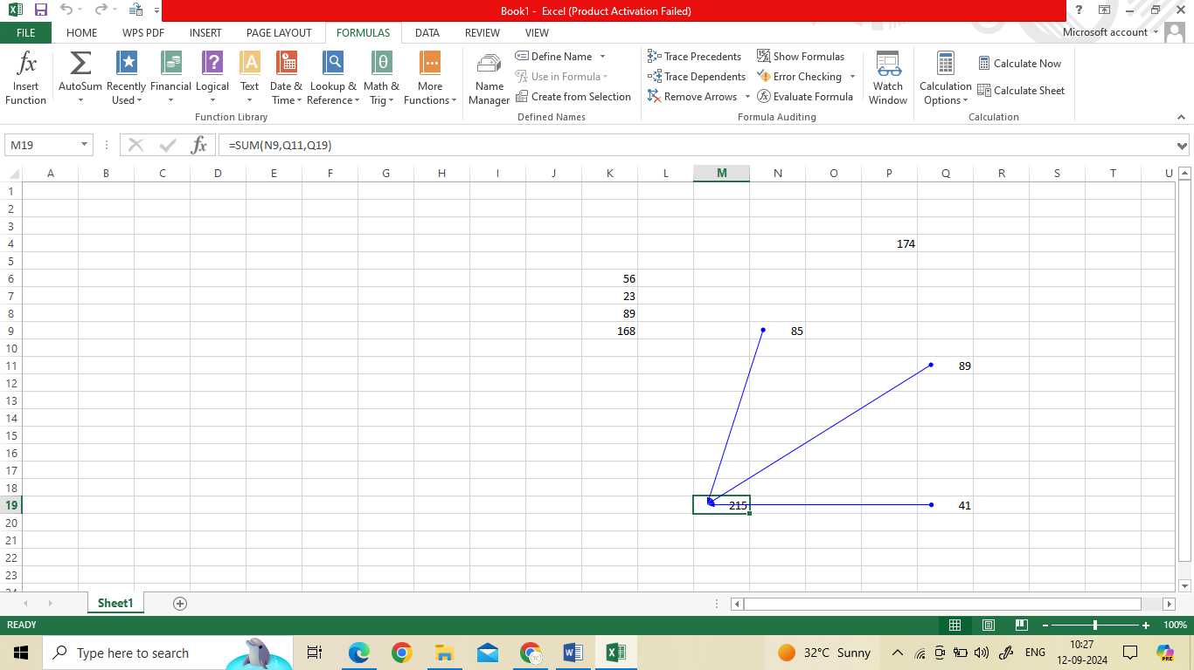

**How to Trace Dependents in Excel**

1. Select the cell you want to trace dependents for.
2. Go to the “Formula Auditing” group on the “Formulas” tab.
3. Click on the “Trace Dependents” button ( or Ctrl + [ ). Excel will draw arrows to show the cells that are affected by the value of the selected cell.
4. If the cell has multiple dependents, you can use the “Trace Dependents” button again to trace the dependents of the dependent cells.
5. To remove the arrows, click on the “Remove Arrows” button in the “Formula Auditing” group.

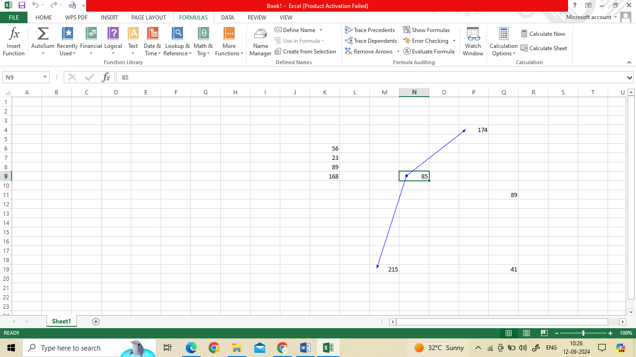

# Chapter 14: Ranges and Dates

## DATE FORMULAS

**1. DATE**

**Syntax**

The syntax of the DATE function is:

DATE(year, month, day)

**2. DATEVALUE**

The DATEVALUE function converts a date formatted as text to a date serial number.

**Syntax**

DATEVALUE carries a single argument.

DATEVALUE(date_text)

**3. DAY**

The DAY function returns the nth day of the month ranging from 1 to 31. This can be useful for isolating the day element of a date.

**Syntax**

The syntax of the DAY function is:

DAY(serial_number)

**4. DAYS**

The DAYS function calculates the number of days between two dates.

**Syntax**

DAYS(end_date, start_date)

**5. EDATE**

The EDATE function returns the date of a future or past month where the day of the month is identical to the date being referenced. The EDATE function may be used to determine maturity, expiry, or due dates.

**Syntax**

EDATE(start_date,months)

**Start_date**will be used as the reference date.

**Months**is the number of months to be calculated before or after the **start_date.**

**6. NETWORKDAYS**

NETWORKDAYS is used to determine the number of working days between two dates

**Syntax**

The syntax of the NETWORKDAYS function is:

NETWORKDAYS(start_date, end_date, [holidays])

**7. NOW**

The NOW function in Excel returns the serial number of the current date and time

**Syntax**

The NOW function has no arguments. The format is:

=NOW()

**8. TODAY**

The TODAY function returns the serial number of the current date in Excel.

**Syntax**

The TODAY function has no arguments. The format is:

=TODAY()

# CHAPTER 15: Lookup

## VLOOKUP Function

The **VLOOKUP** function is a premade function in Excel, which allows searches across columns.

It is typed =VLOOKUP and has the following parts:

=VLOOKUP(**lookup_value**, **table_array**, **col_index_num**, [**range_lookup**])

**Lookup_value:** Select the cell where search values will be entered.

**Table_array:** The table range, including all cells in the table.

**Col_index_num:** The data which is being looked up. The input is the number of the column, counted from the left

## ****HLOOKUP()**** function

**HLOOKUP()** function is used when the user tries to find a value in a table by matching a lookup value in the first row of the table.

**Syntax**

***=HLOOKUP(lookup_value, table_array, row_index_num, [range_lookup])***